Robotic finger instructions

- To make a finger, take 3 of the 2 cm x 3 cm pieces of cardboard.
- Place the 3 equal finger pieces together and use tape to connect all of them (See diagram below).
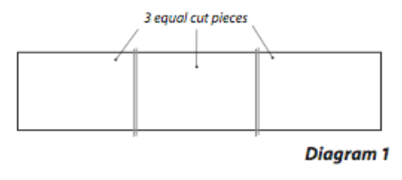

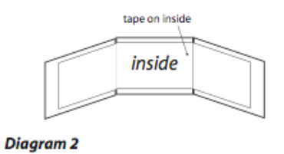

- Remember that the side of the finger that has tape on it is the inside of the finger.
- Turn the finger over so that the “inside” is face down.
- Take a 2.5 cm piece of rubber band and attach it across the first joint (see next diagram).

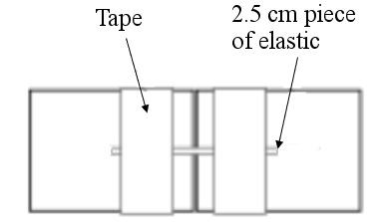
- Repeat step 5 for the second joint.
- Tape the finger onto the palm with the “inside” facing up.
- Turn the hand over.
- Cut a rubber band 2.5 cm long.
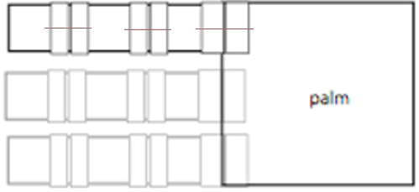
- Put the rubber band across the last joint (touching the palm) (See diagram below).

- Cut a piece of cord 35 cm long.
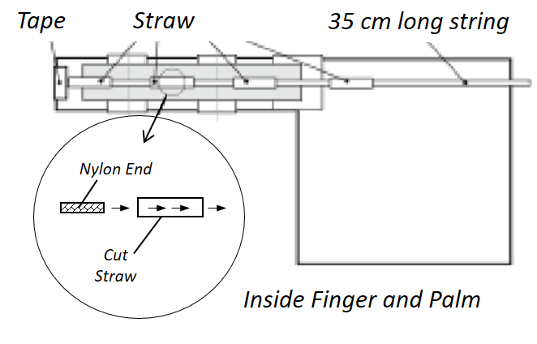
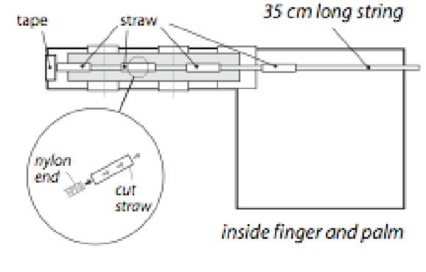
- Tape one end of the cord over the end of the finger (see diagram below).

- Cut 4 pieces of straw 2 cm each.
- Thread the pieces of straw onto the nylon cord.
- Tape a piece of straw in the middle of each finger section.
- Tape the last straw to the palm (see previous diagram).
- Repeat step 1-16 for as many fingers as you would like.

